Molecular Reactions

This document describes design decisions made on 9/21/2006 by Linda Koch, Trish Loeblein, Kathy Perkins and Ron LeMaster

Simple Module
The general appearance of the module is shown in this drawing.
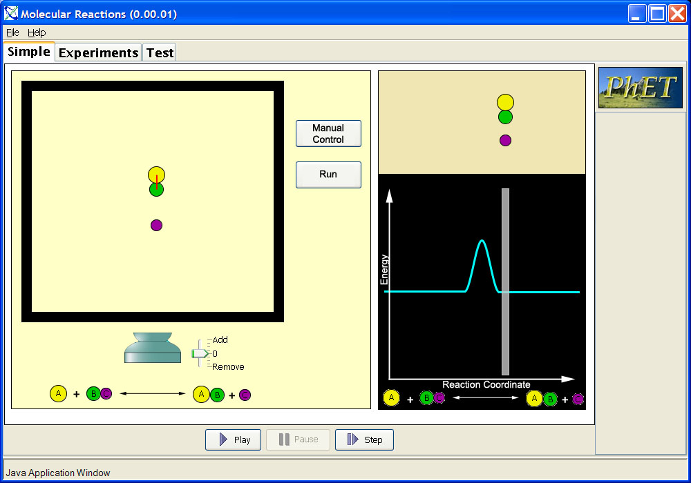
The first module with have just three bodies. There will be no controls for adding or removing any bodies.
The bodies will move vertically in the middle of the box, rather than horizontally.
There will be a button that will enable the user to enter a manual control mode in which he or she will be able to move the gray bar in the energy view left and right. This will move the bodies closer and farther apart, and to one side of the reaction to the other. In the manual control mode, the user will also be able to drag any of the bodies in the box with the mouse up and down.
There will be another button that will set the simulation in the normal run mode.

Multiple Body Module
The general appearance of the module is shown here.
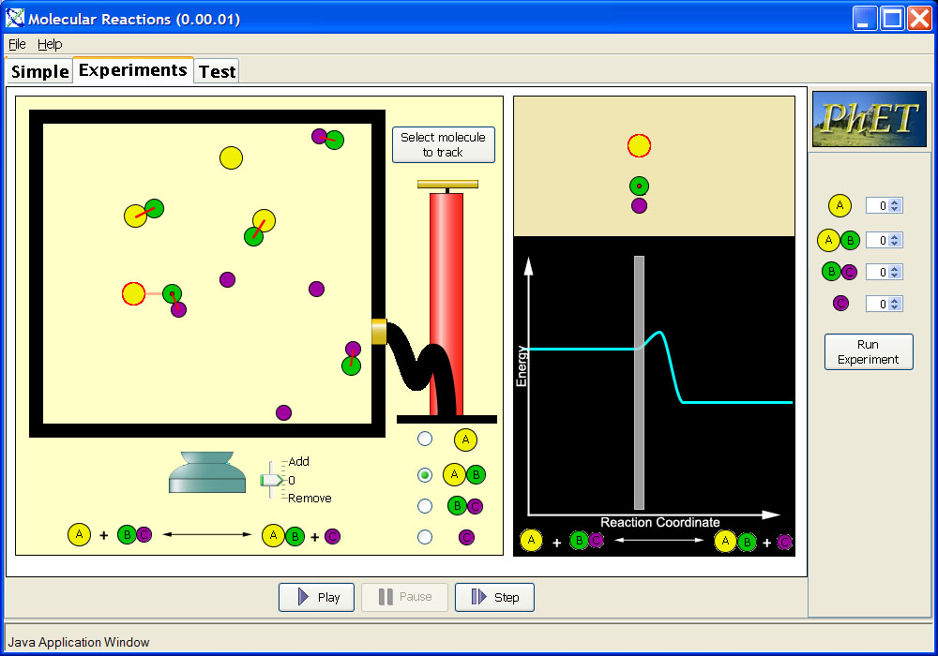
The user-selected body will be marked with a halo. The body nearest to the selected body that can react with the selected body will be marked by a dot.

Features Common to All Modules

Energy Profile Manipulation
The user will be able to adjust with the mouse the sloping sides of the hump in the energy profile. Each side will be independently adjustable. When adjusted, the sloping side being adjusted will snap to the nearest of three positions. The positions will be determined by points spaced evenly along the profile as shown by the short beige lines in the following image. Note that these lines won’t appear on the screen. They are shown here only to depict where the snap-top points will be.
